

School of Computer Science Engineering & Information Systems (SCORE)

WINTER SEMESTER 2025-2026

Name: M. Divyasri
Registration Number: 23MIS0174
Course Title: Agile Development Process and Devops Lab
Course Code: ISWE406P
Faculty: Dr. Sweta Bhattacharya
Slot: L3+L4

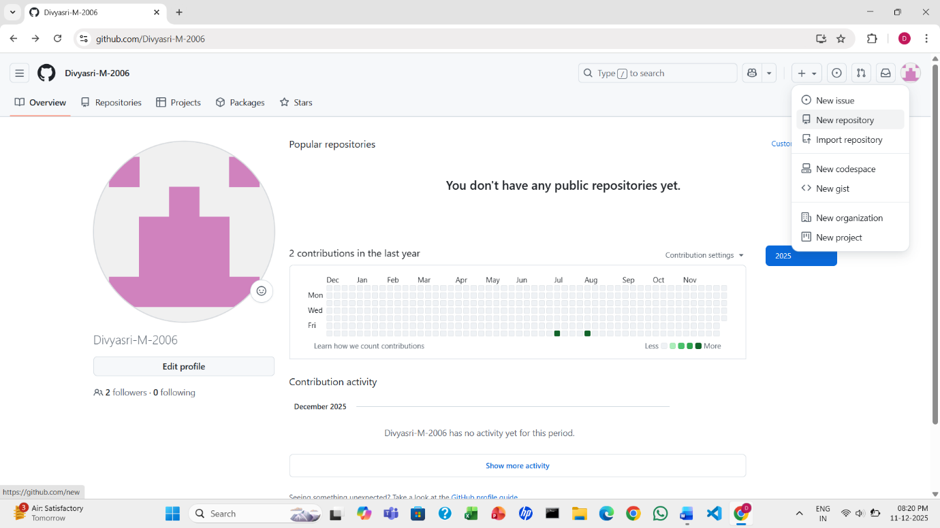
1. Open GitHub, go to your profile, click the ‘+’ symbol, and select ‘New repository

2. Next, enter the repository name.
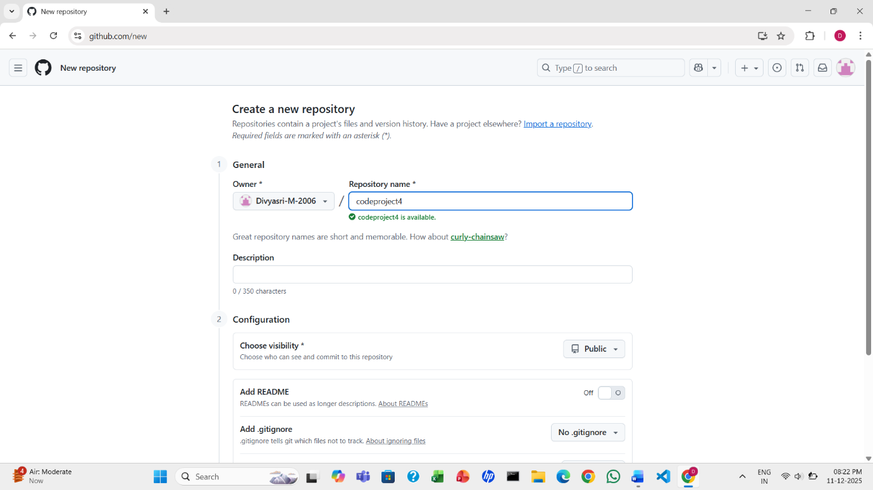

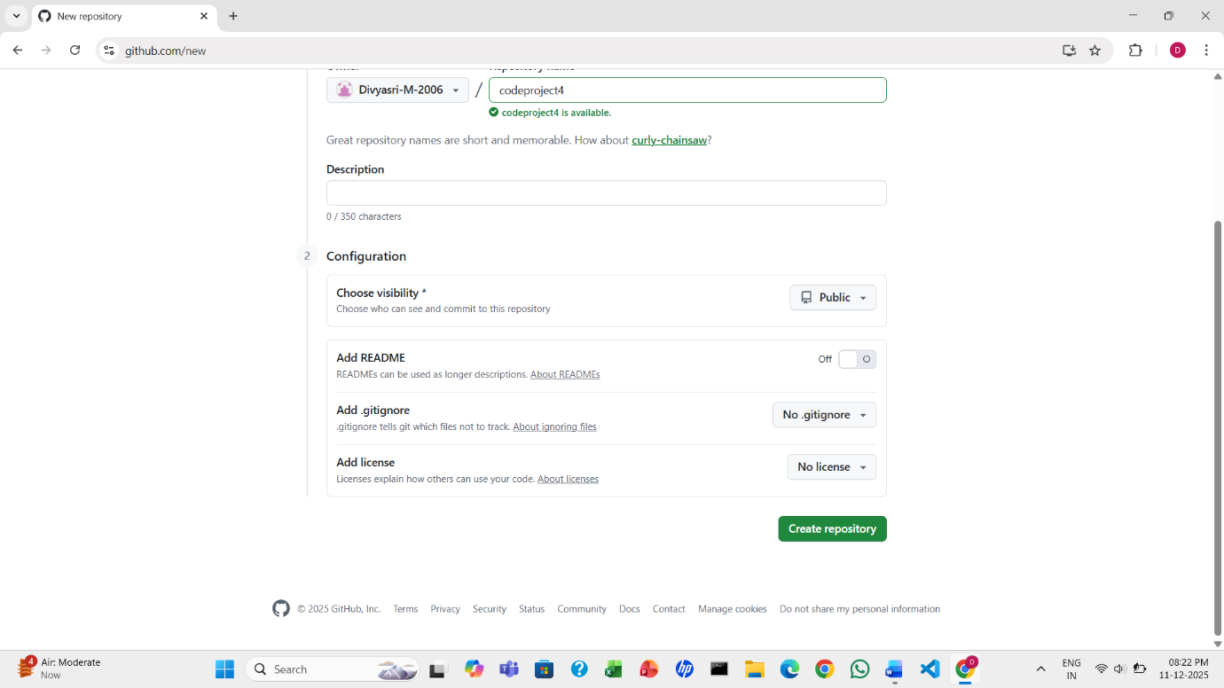
3. Click Create repository.

4. After creating the repository, you will see the following screen.
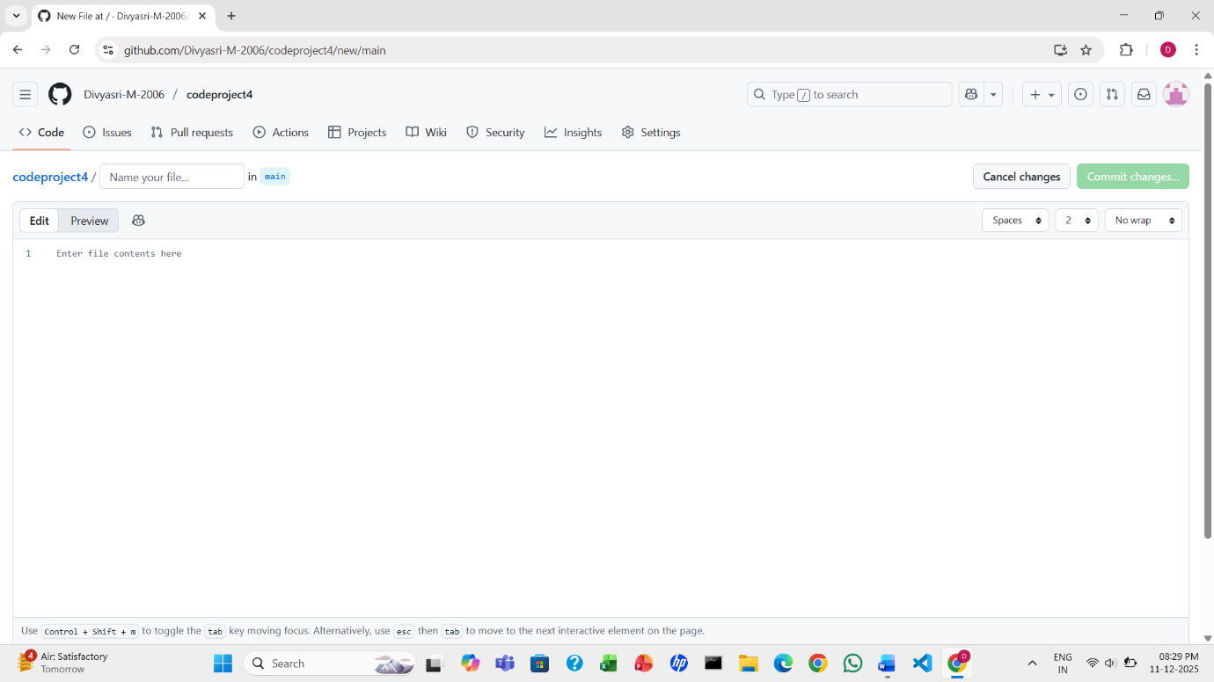

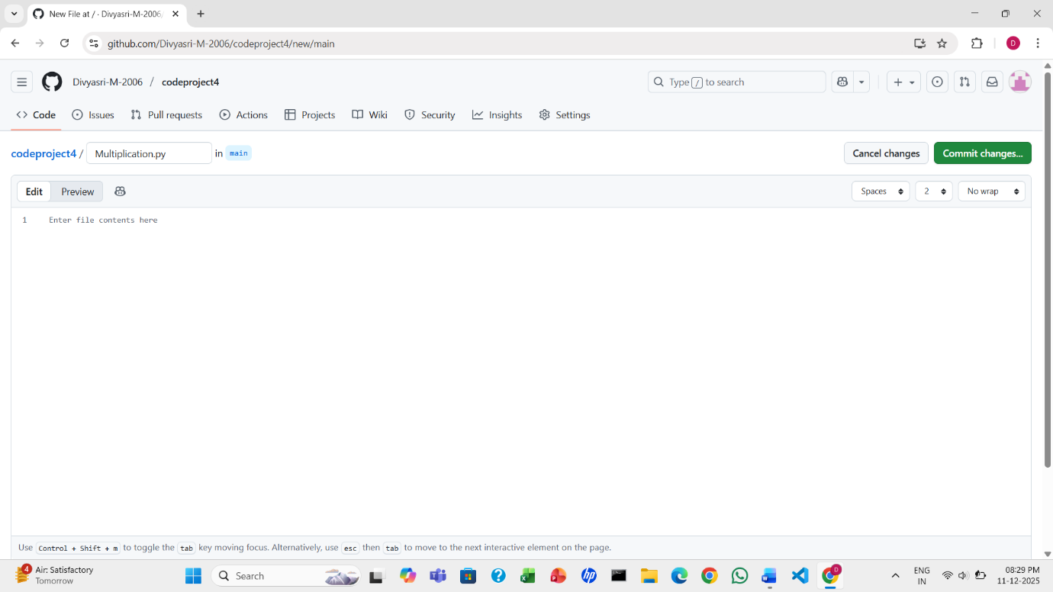
5. Now, enter the file name.

6. Enter the code in the editor, then click Commit changes.
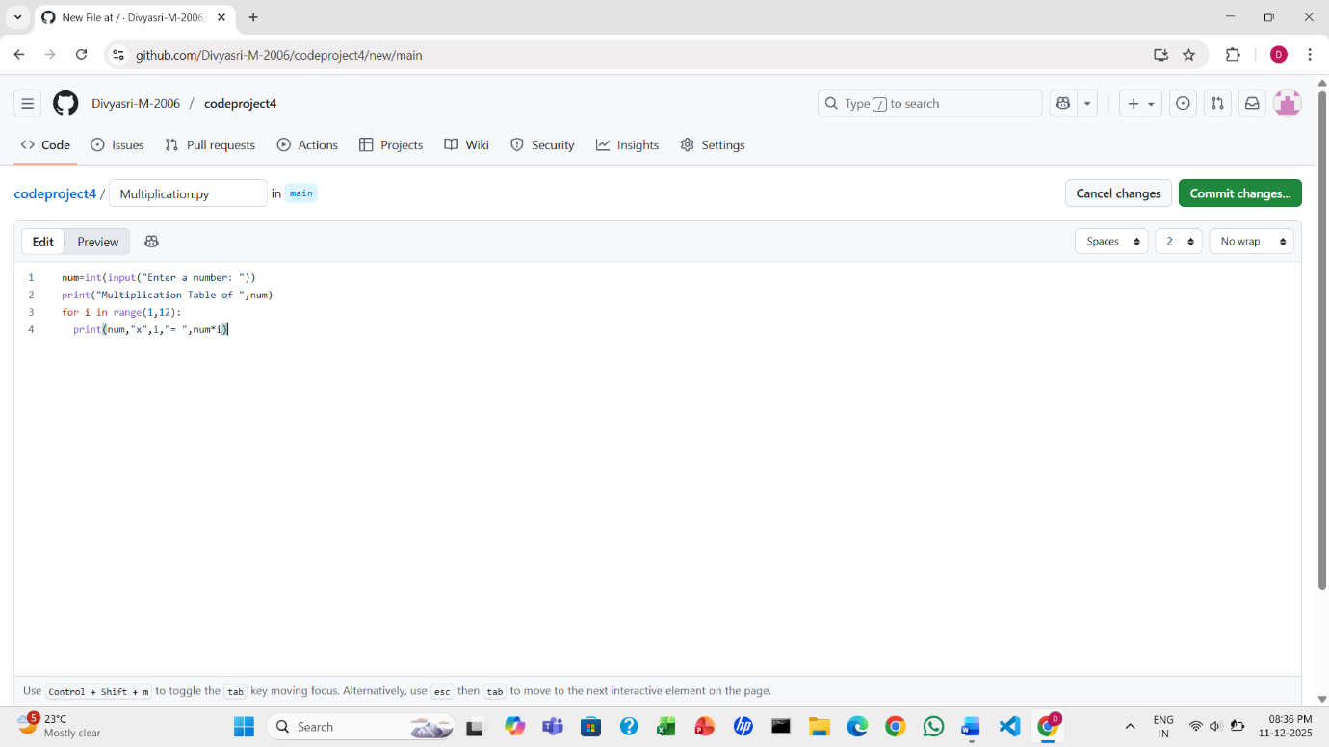

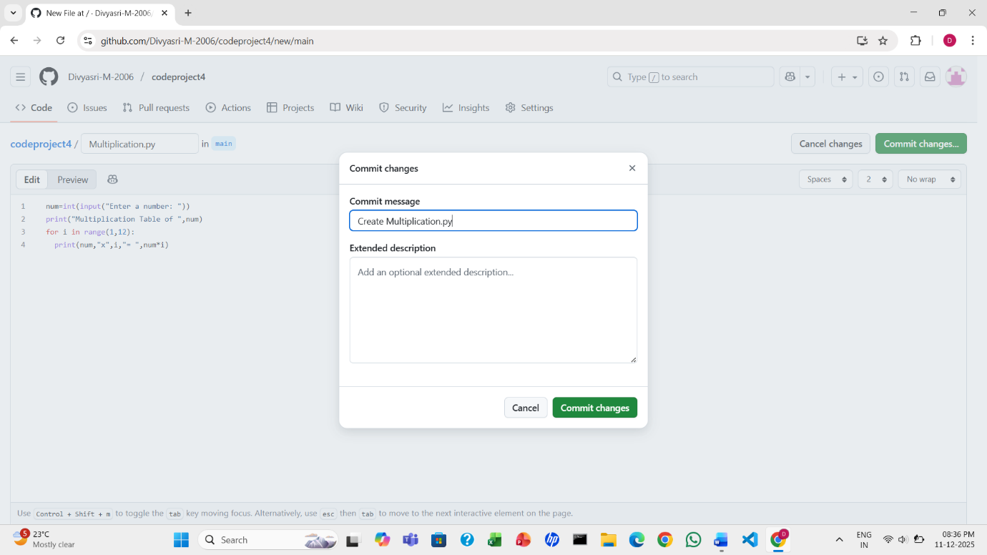
7. Click commit changes to save the file.

8. After the file is created, you will see the following screen.
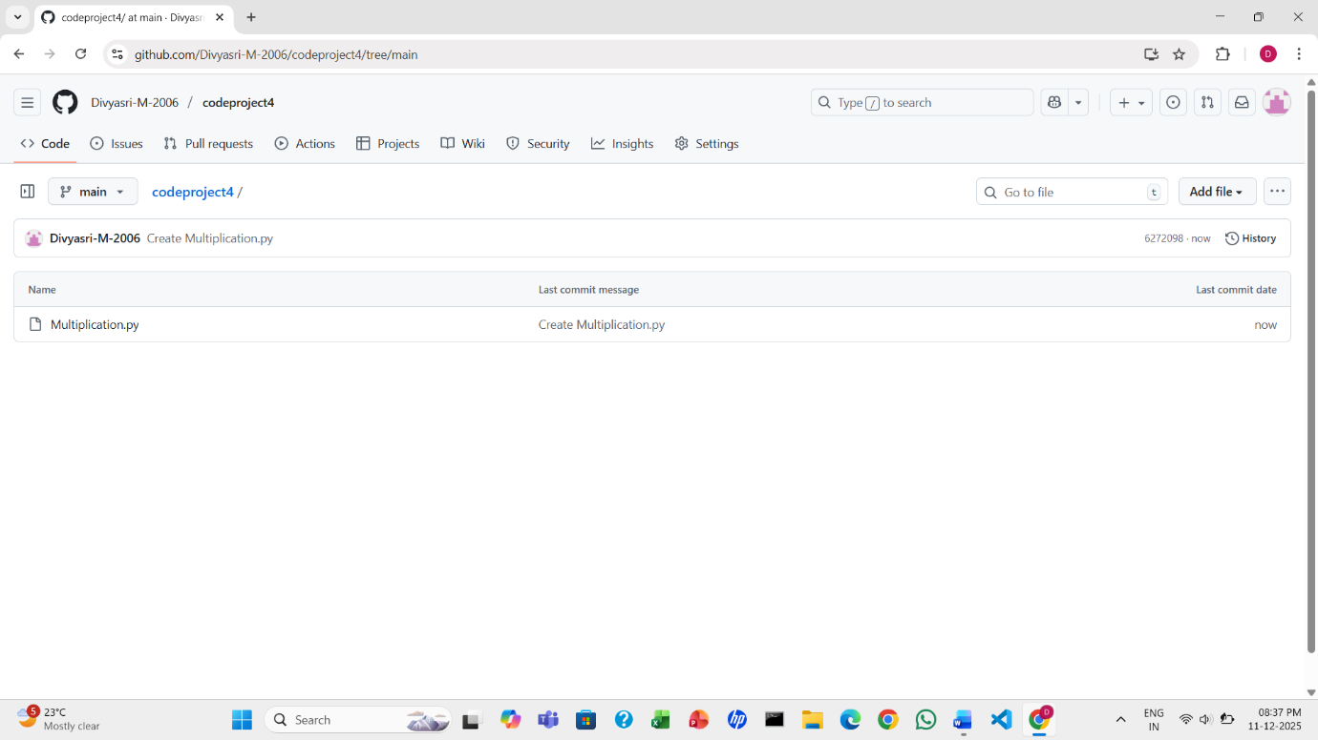

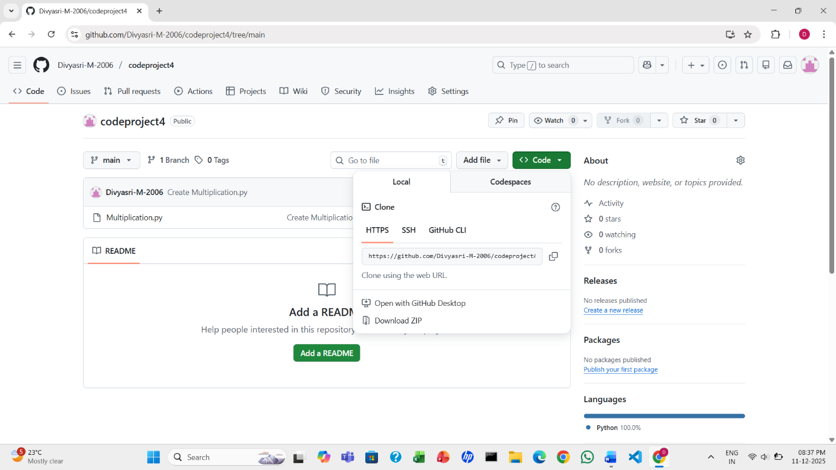
9. Click Code, then copy the URL.

10. Open Visual Studio Code and click Clone Git Repository.
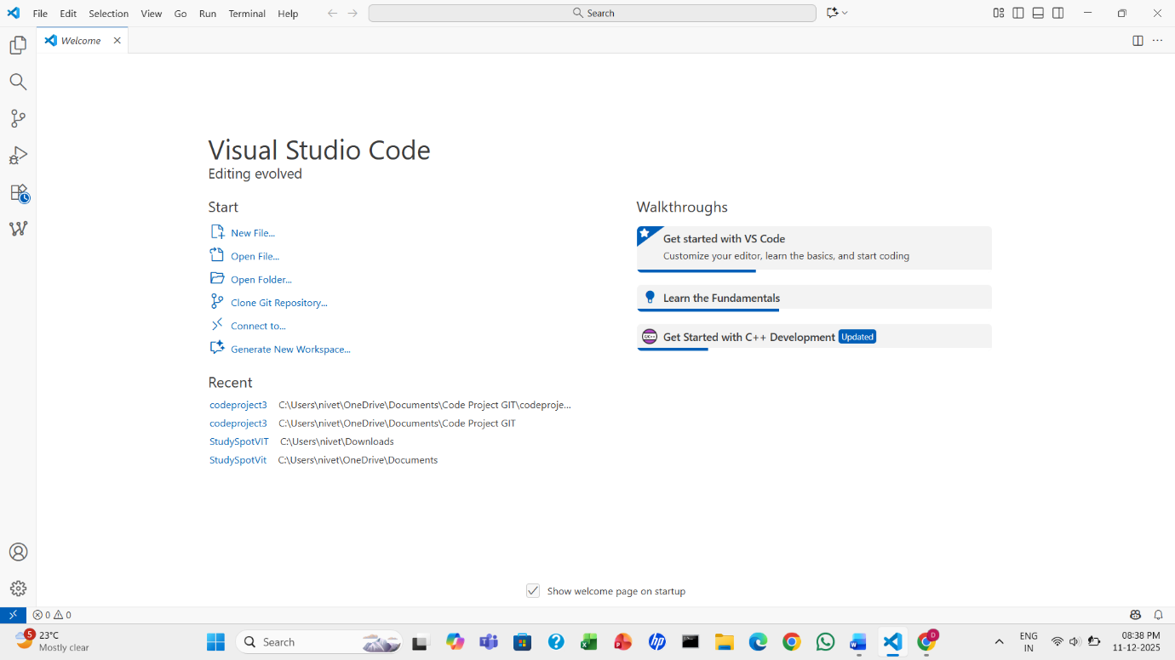

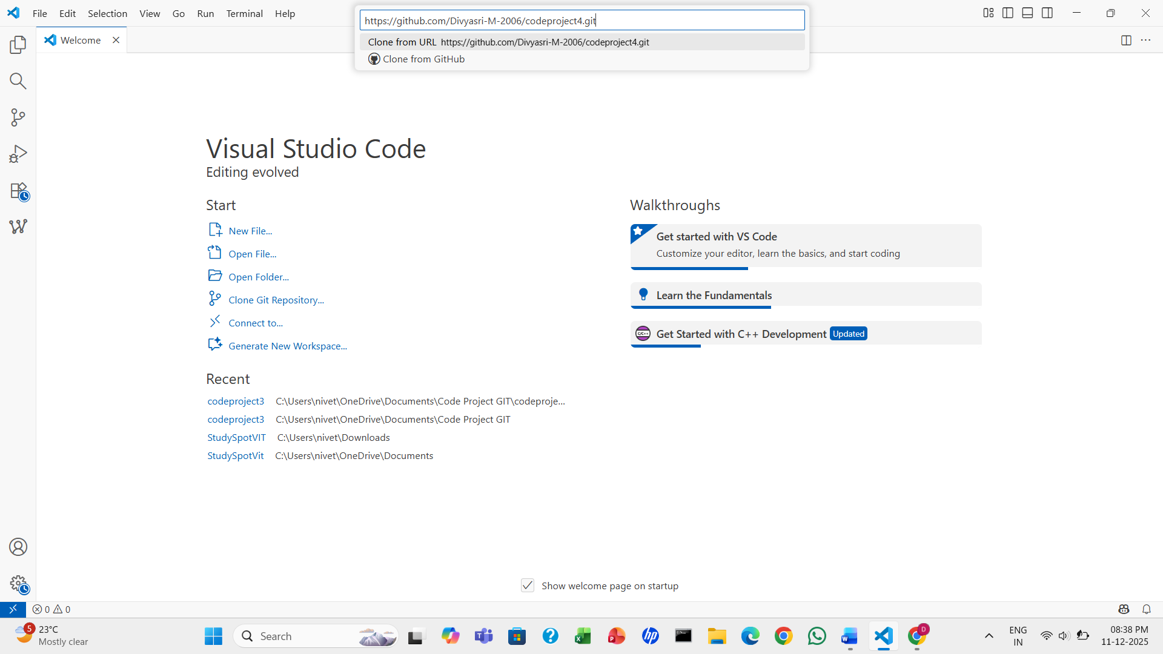
11. Paste the URL and press Enter.

12. Create any folder and then click Select as Repository Destination.
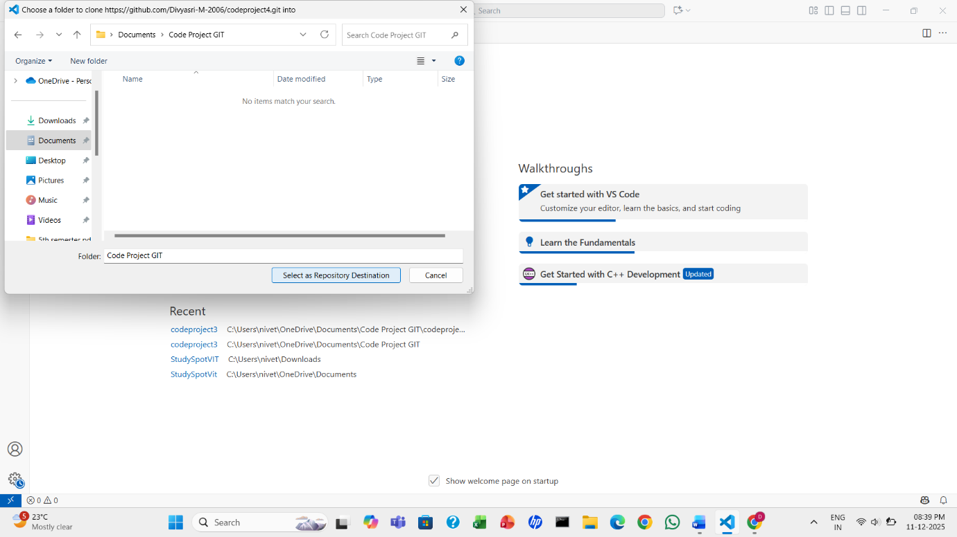

13. Click open.
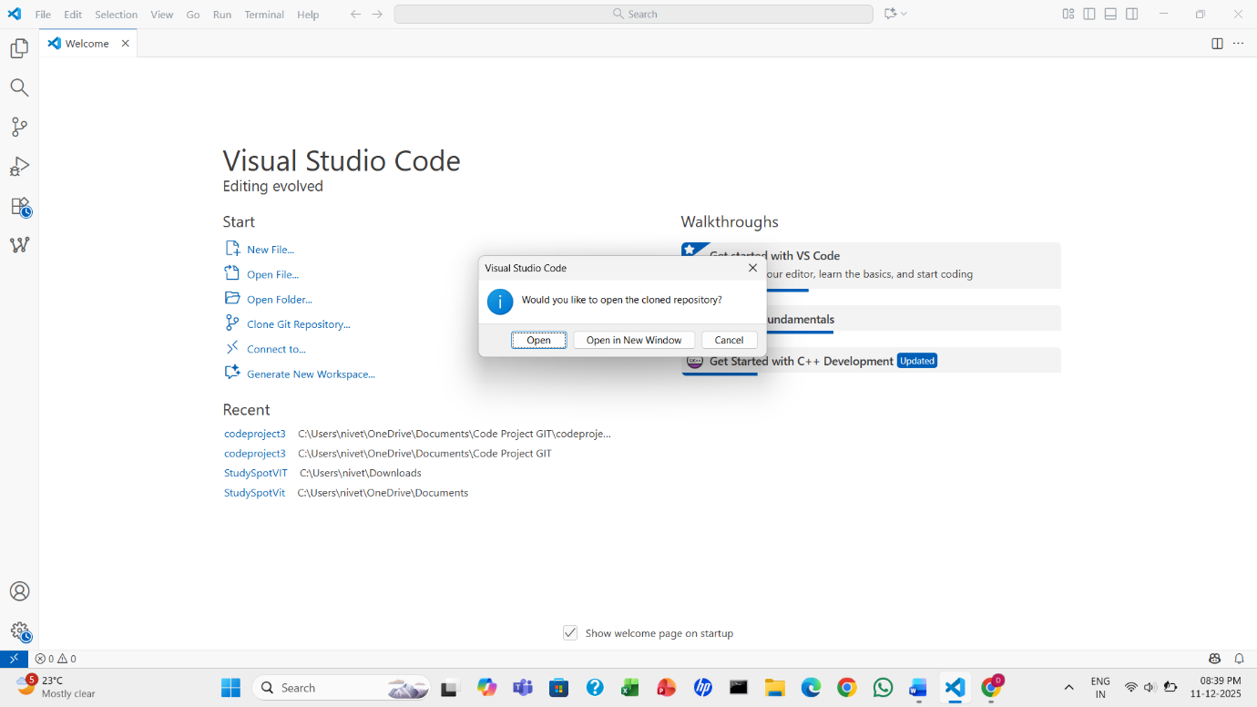
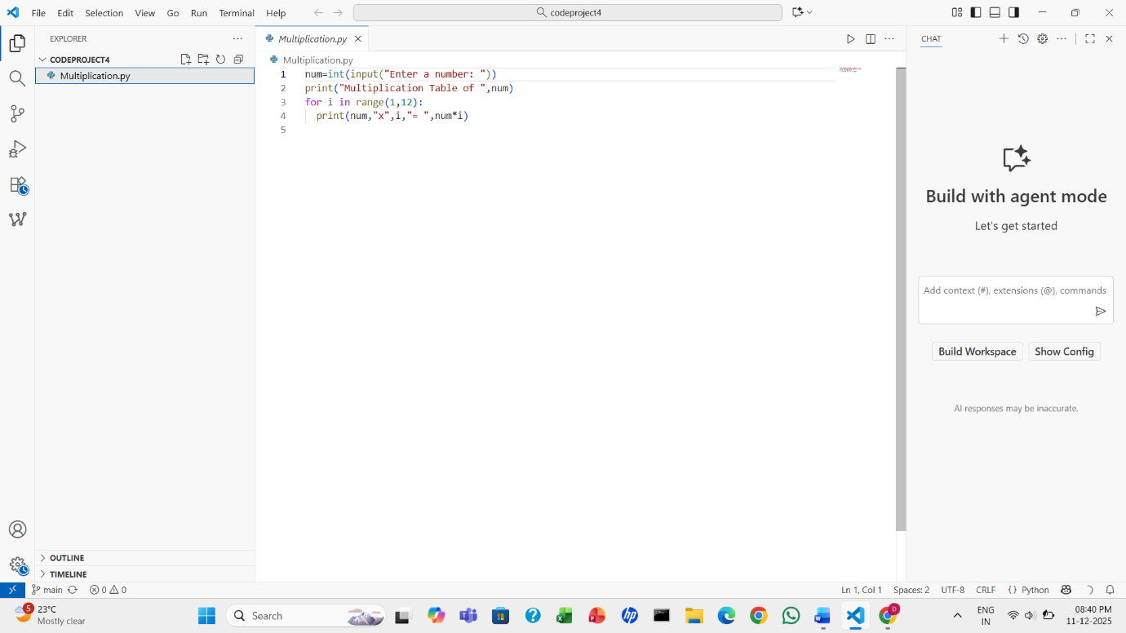
14. Now you will see the file you saved in Git. In the top menu, click Terminal.

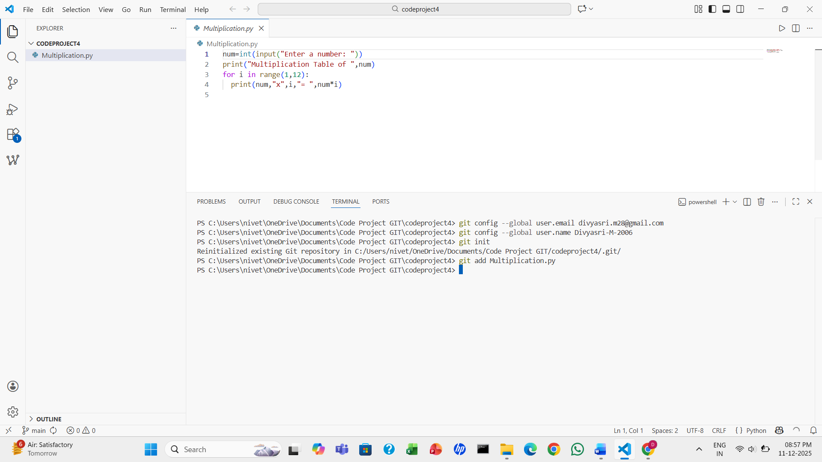
15. Configure Git with your username and email, then initialize the repository using git init.

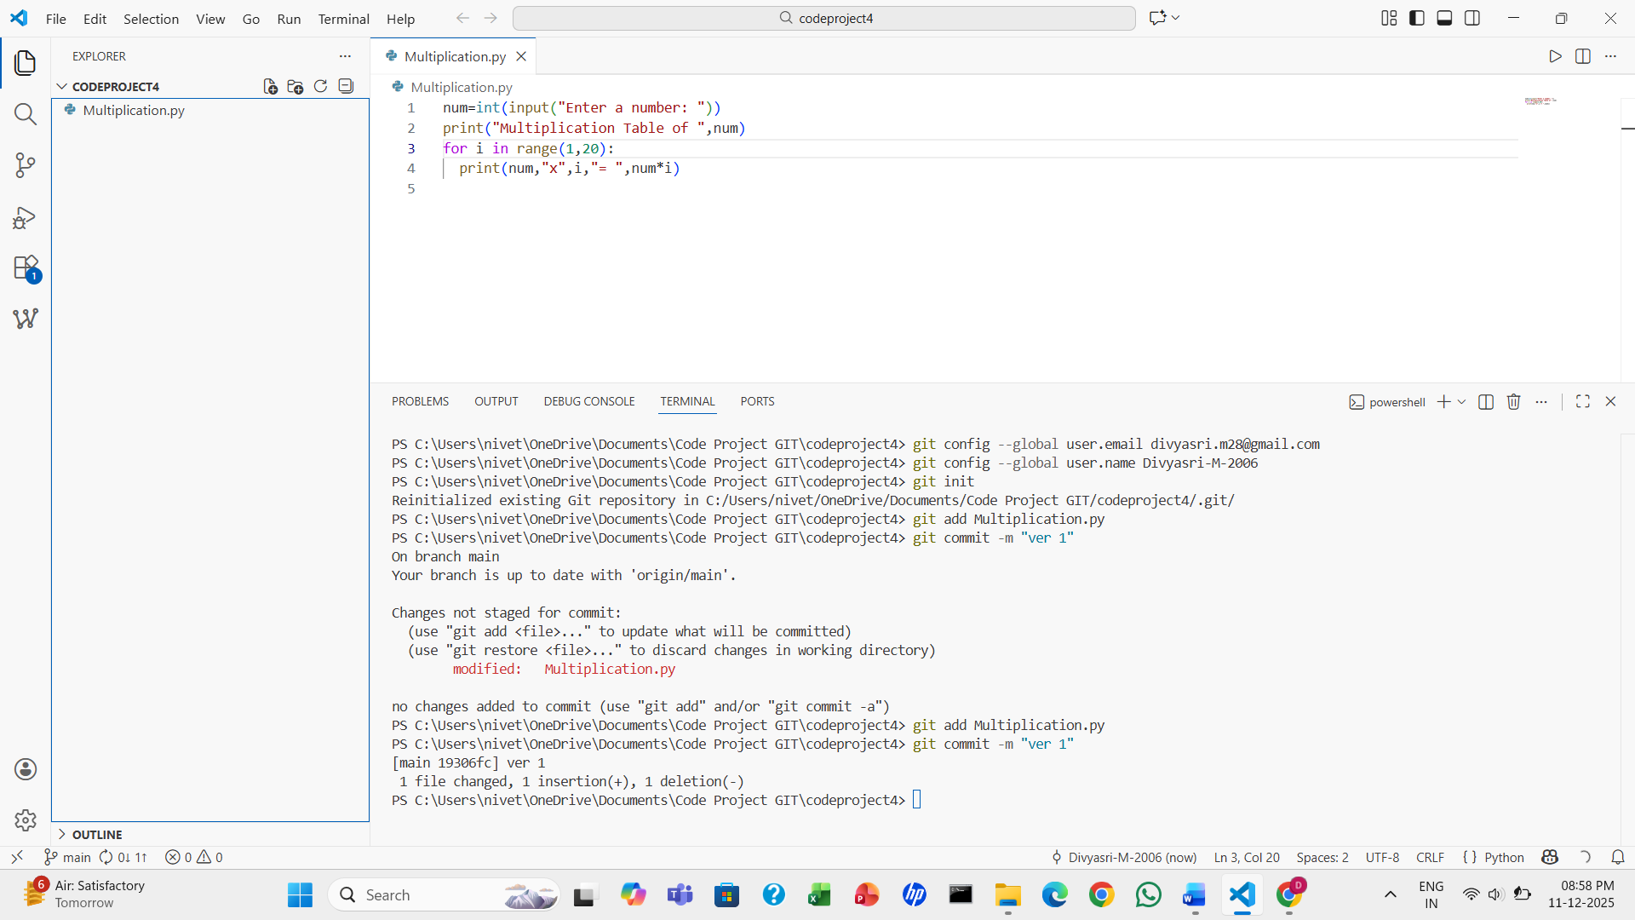
16. After changing the code, run git add and git commit to save your changes.

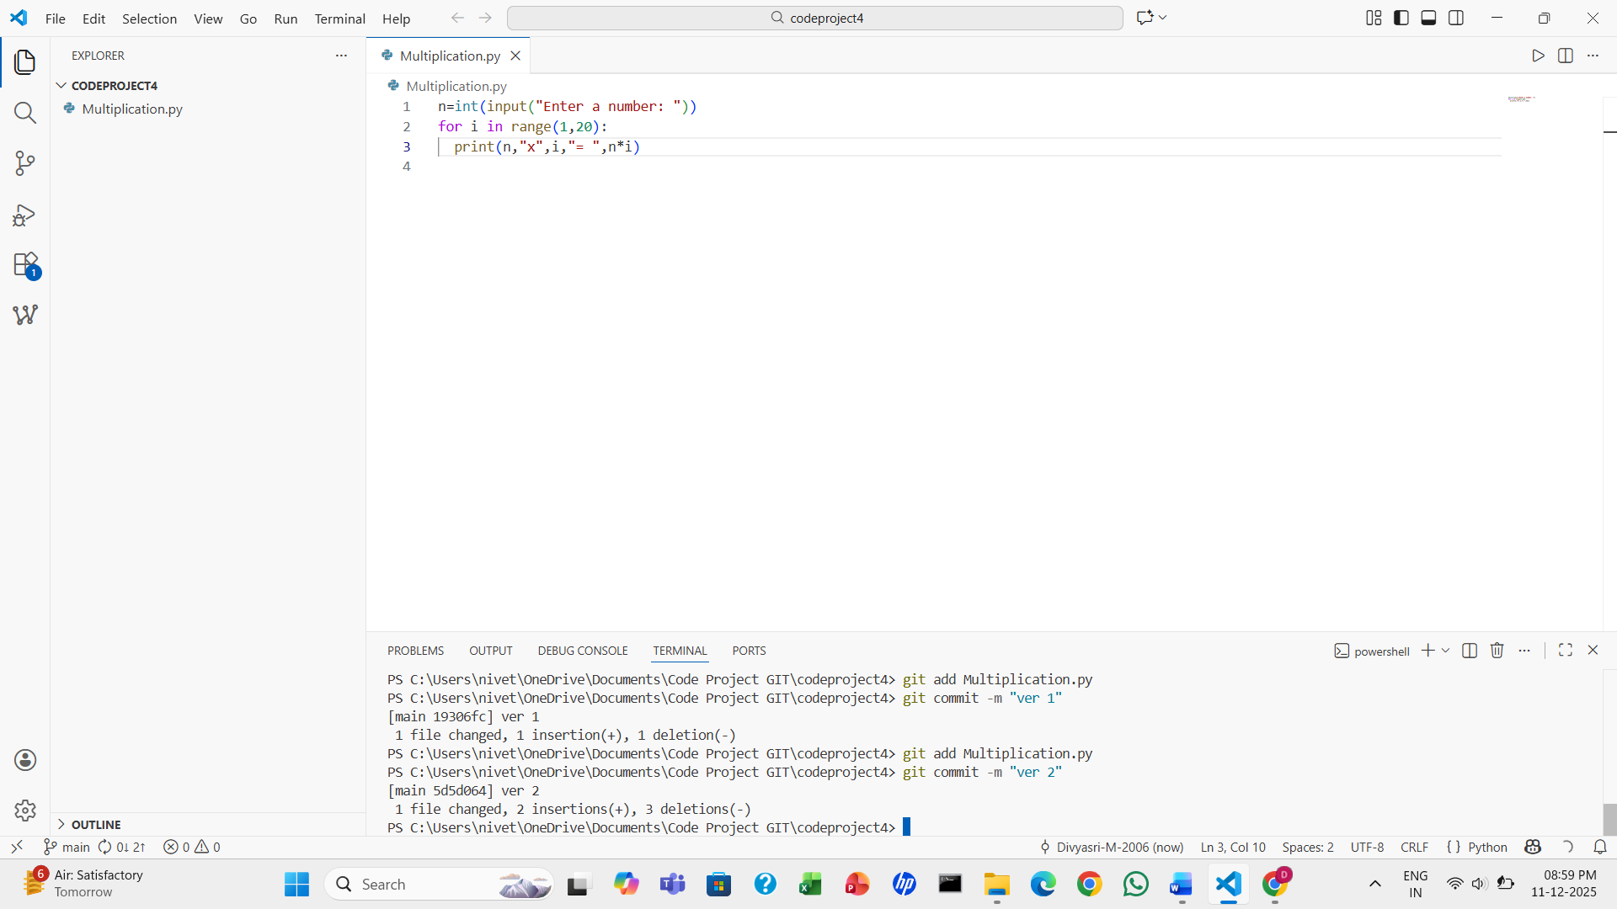
17. Additional changes can be made and committed as a new version.

18. In the Explorer, you will see Timeline. Click on it.
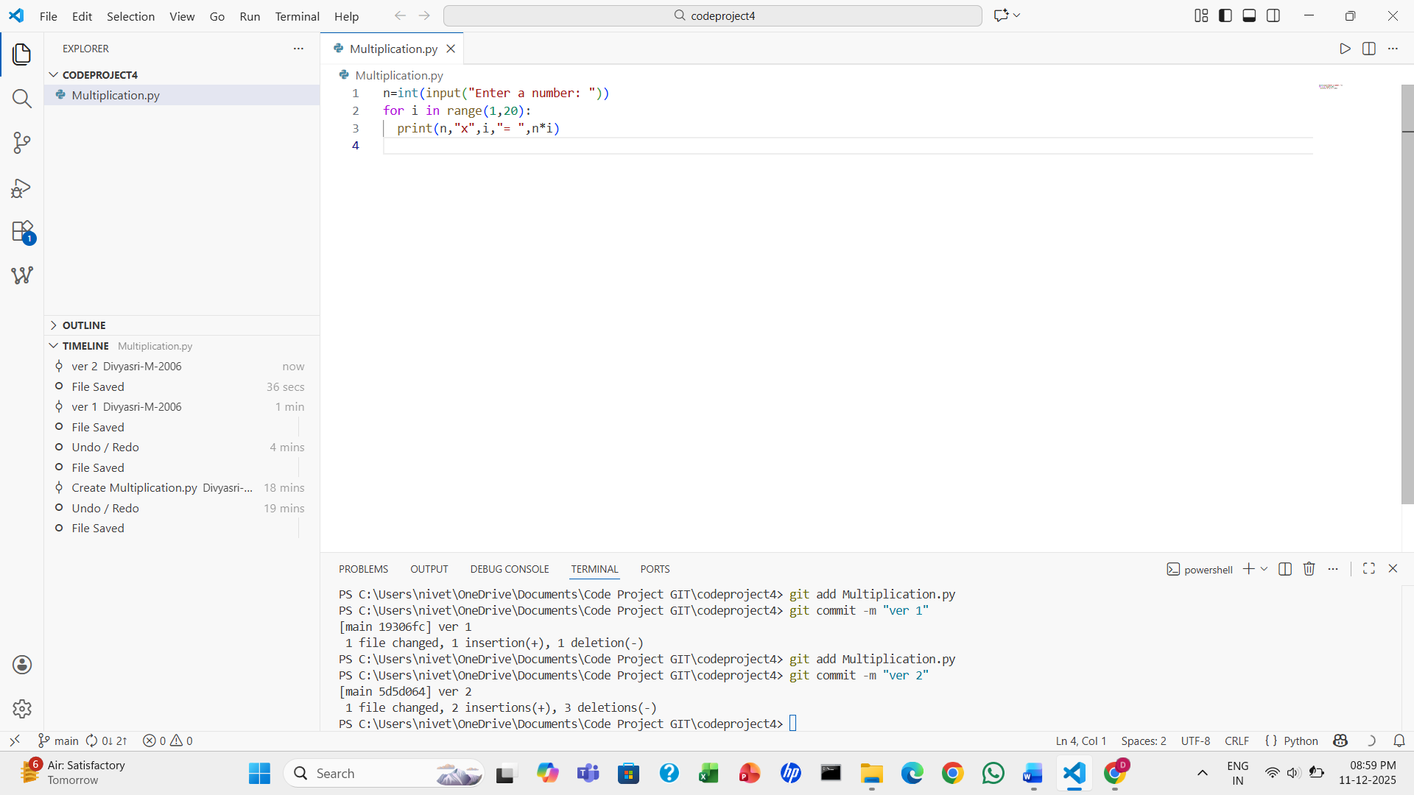

19. Click on the Ver 1 file to see the changes you made.
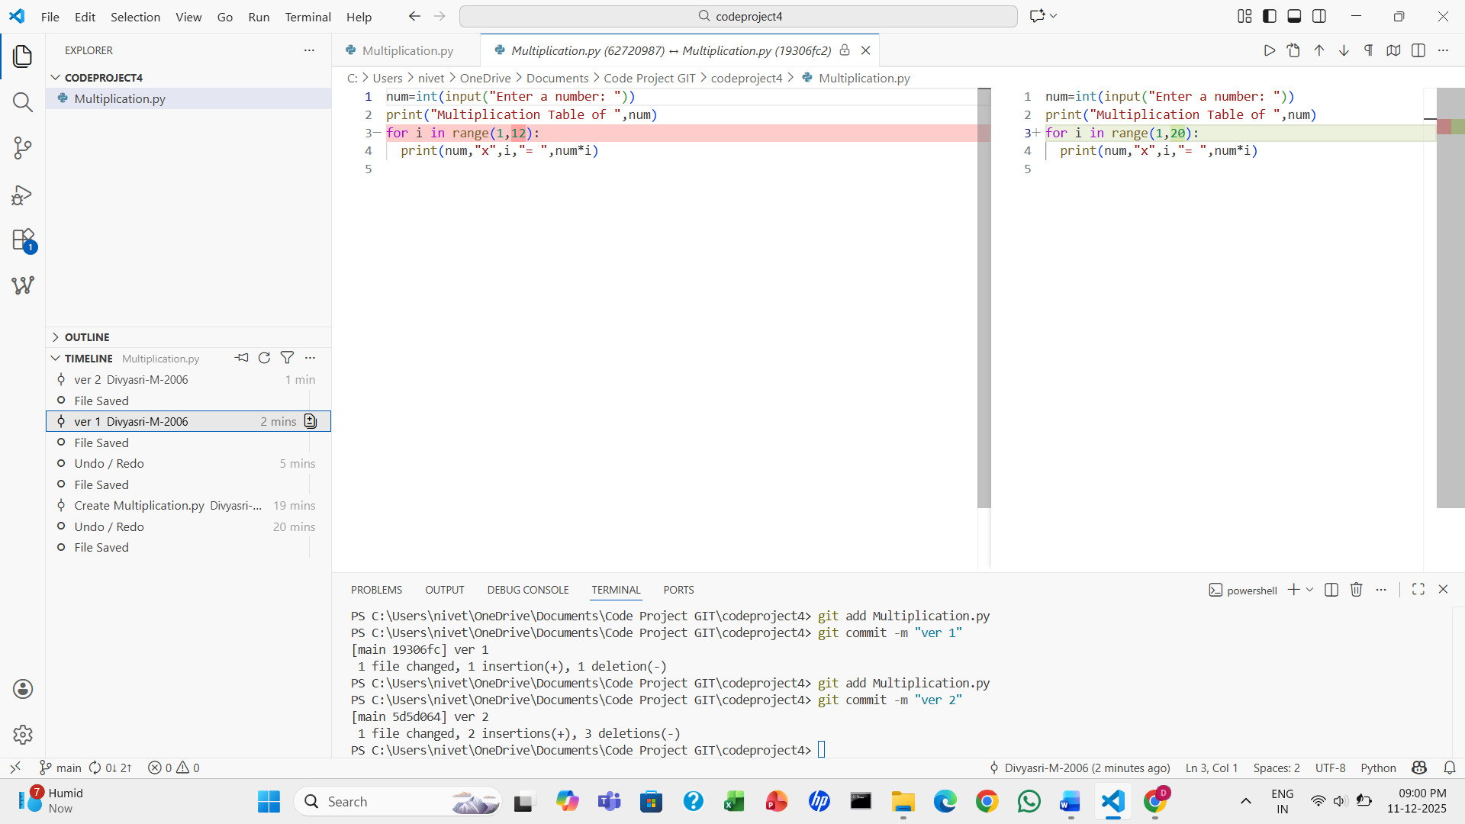

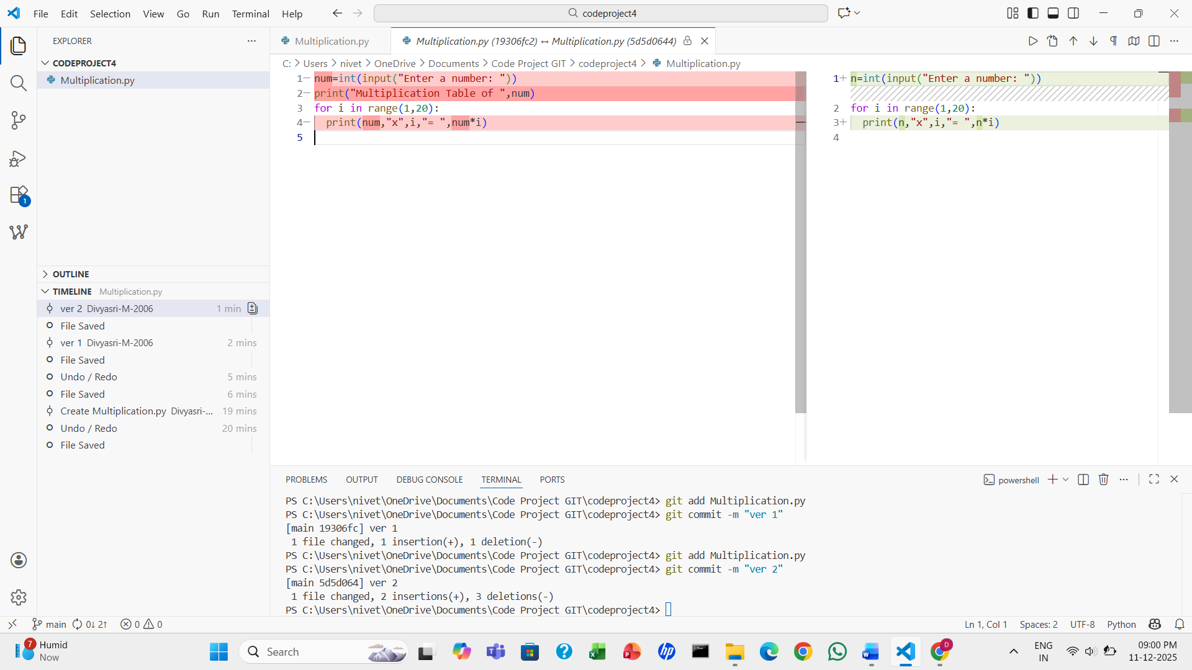
20. Now click on the Ver 2 file to see the changes you made next.

